Course Number | CPS 8319
Course Title | Reinforcement Learning
Semester/Year
Section Number
Group Number | 7

Assignment No.1

Assignment Title | Question 1, UCB algorithm
Submission Date | 2026-02-04
Due Date
`  Student Name | Student ID (xxxx1234) | Signature*
John Cook-Martin | 2923 | J.CM
Pari Qarehdaghi | 4602 | P.Q
(Note: Remove the first 4 digits from your student ID)

Contents
Introduction 3
Problem Description 3
Methodology 3
Results 5
Normalized Optimal Pulls 5
Normalized Optimal Value 7
Discussion 10
Conclusion 10

Figure 1: Normalized Optimal Pulls – Experiment 1 5
Figure 2: Normalized Optimal Pulls – Experiment 2 5
Figure 3: Normalized Optimal Pulls – Experiment 3 6
Figure 4: Normalized optimal pulse - Experiment 4 6
Figure 5: Normalized Optimal Value – Experiment 1 7
Figure 6: Normalized Optimal Value – Experiment 2 8
Figure 8: Normalized Optimal Value – Experiment 4 9
Figure 7:Normalized Optimal Value – Experiment 3 9

Introduction

The multi-armed bandit problem represents the trade-off between exploration and exploitation in reinforcement learning. To maximize cumulative reward, an agent repeatedly selects from a finite set of actions (arms), each associated with an unknown reward distribution.
This report analyzes the Upper Confidence Bound (UCB) algorithm through simulation. UCB is a principled exploration strategy that chooses actions based on both reward estimates and uncertainty estimates. Over multiple experimental runs, the performance of UCB is evaluated using normalized optimal pull percentages and normalized optimal value convergence. (Sutton and Barto)

Problem Description
In this problem, ten actions are available (choices 0–9) in a stochastic bandit environment. A fixed but unknown reward distribution is associated with each action. The agent interacts with the environment for many rounds and selects actions according to the UCB policy. (Sutton and Barto)
In this experiment, we aim to:
- To analyze how quickly the UCB algorithm identifies the optimal action
- To observe long-term action selection behavior
- To determine whether the estimated reward is converging toward the true optimal reward

Methodology
The UCB algorithm selects actions according to:
$$a_{t}=arg⁡\underset{a}{max⁡}\left({\hat{Q}}_{t}(a)+c\sqrt{\frac{\ln{t}}{N_{t}(a)}}\right)$$
where:
- ${\hat{Q}}_{t}(a)$is the estimated mean reward of action $a$
- $N_{t}(a)$is the number of times action $a$has been selected
- $t$is the current time step
- $c$is a confidence parameter controlling exploration
In the reported experiments, the confidence parameter was fixed at $C=1$, providing a balanced trade-off between exploration and exploitation.
In this implementation, action-value estimates ${\hat{Q}}_{t}(a)$were updated incrementally using the standard averaging rule described in Chapter 2 of the textbook, while action counts $N_{t}(a)$were updated after every action selection.
Several values of the confidence parameter $c$ were explored during development. It was observed that larger values of $c$resulted in excessive exploration, while smaller values slowed down convergence. Based on these observations, a fixed value of $c$that provided stable and efficient learning behavior was selected for the reported experiments.
Each experiment was repeated across multiple independently generated bandit environments, each defined by a different set of reward probabilities. The reported results are averaged over these runs to reduce variance and highlight general learning behavior.
The following performance metrics were recorded:
- Normalized Optimal Pulls: the proportion of times each action is selected
- Normalized Optimal Value: the ratio of the estimated reward to the true optimal reward
Results are plotted as functions of the number of rounds. (Sutton and Barto)

Results

Normalized Optimal Pulls
The normalized optimal pull plots illustrate how frequently each action is selected as learning progresses.

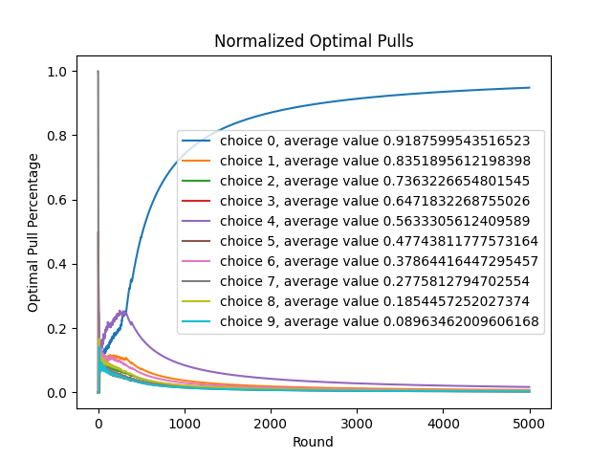
Figure 1: Normalized Optimal Pulls – Experiment 1
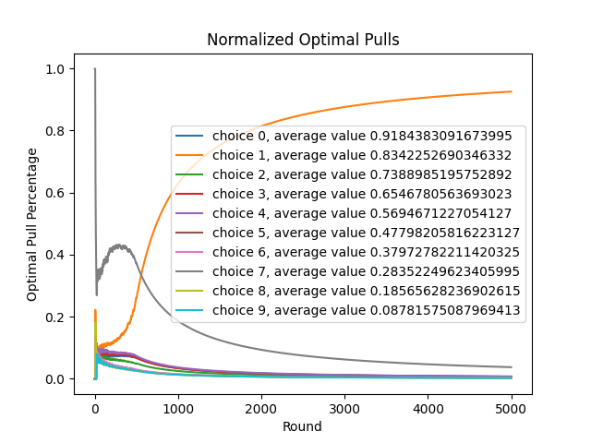
Figure 2: Normalized Optimal Pulls – Experiment 2

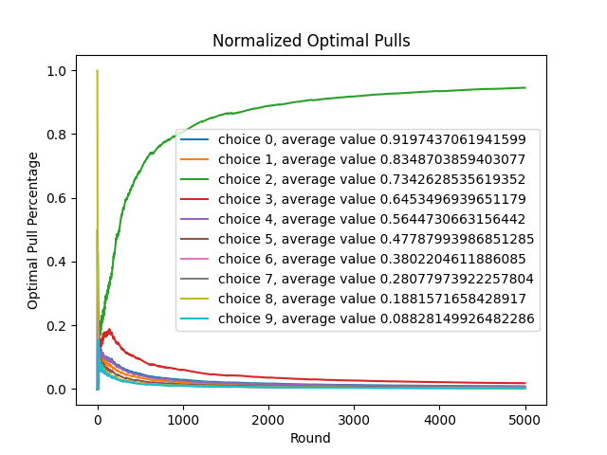
Figure 3: Normalized Optimal Pulls – Experiment 3

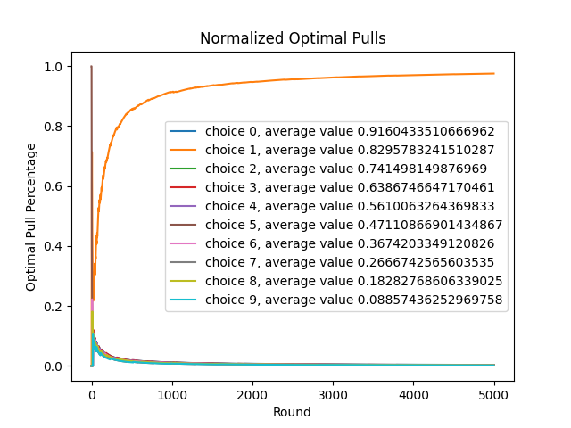
Figure 4: Normalized optimal pulse - Experiment 4
From these figures, it is observed that:
- In early rounds, multiple actions are explored due to high uncertainty.
- As learning proceeds, the optimal action increasingly dominates the selection process.
- Suboptimal actions gradually decay toward near-zero selection frequency.
- By later rounds, the optimal action is selected in more than 90% of the trials.
This behavior demonstrates the effective exploration–exploitation balance achieved by the UCB algorithm.

Normalized Optimal Value
The normalized optimal value plots show the convergence of the estimated reward toward the true optimal reward.
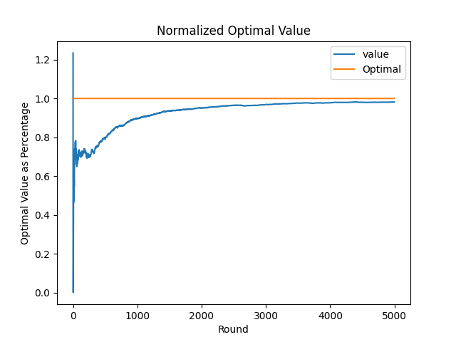
Figure 5: Normalized Optimal Value – Experiment 1
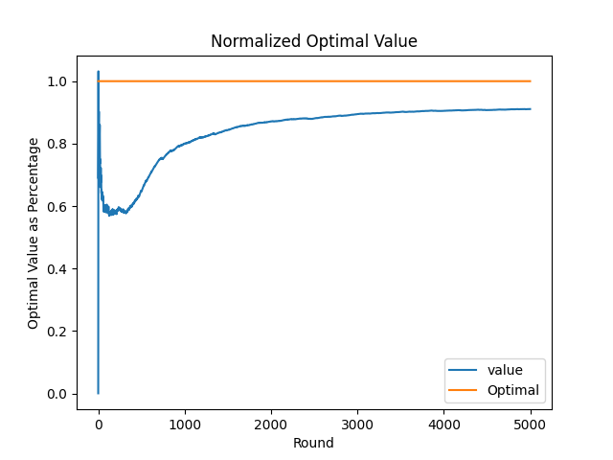
Figure 6: Normalized Optimal Value – Experiment 2
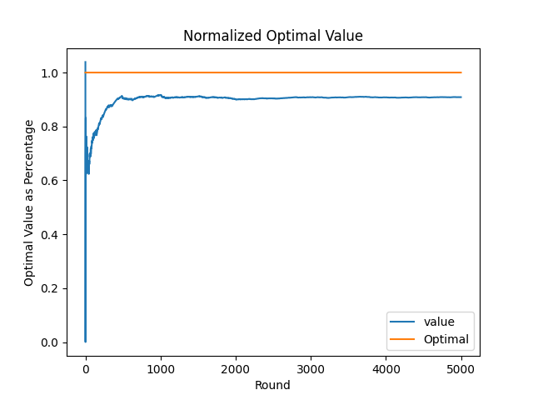
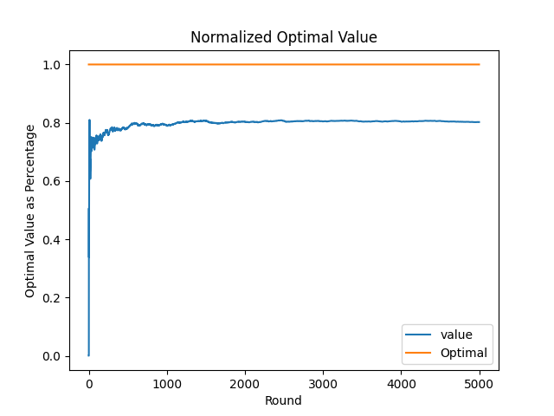
Figure 8: Normalized Optimal Value – Experiment 4
Figure 7:Normalized Optimal Value – Experiment 3
The results indicate that:
- Initial value estimates exhibit noticeable variance due to limited samples.
- As more samples are collected, the estimated value steadily increases.
- In all experiments, the estimated value converges close to the optimal reference line.
- Minor fluctuations persist due to the stochastic nature of rewards.

Discussion
The experimental results confirm that the UCB algorithm efficiently identifies the optimal action in a stochastic bandit setting. The normalized optimal pull plots clearly show a transition from broad exploration to consistent exploitation of the optimal arm.
Compared to purely greedy strategies, UCB ensures sufficient exploration without relying on random action selection. Although the algorithm may initially over-explore certain suboptimal actions, this behavior diminishes as confidence bounds shrink and more information is accumulated.
The normalized optimal value plots further support the effectiveness of UCB, demonstrating stable convergence toward the optimal reward. Differences in convergence speed across experiments can be attributed to stochastic variations in early reward observations and environment initialization.

Conclusion
This report presented a performance analysis of the Upper Confidence Bound algorithm applied to a multi-armed bandit problem. Using normalized optimal pull and normalized optimal value metrics, the algorithm was shown to successfully balance exploration and exploitation.
The results demonstrate that UCB consistently converges toward optimal behavior within a finite number of rounds and maintains strong long-term performance. These findings validate the suitability of the UCB algorithm for stochastic decision-making problems where uncertainty must be systematically managed.

References (MLA)
Sutton, Richard S., and Andrew G. Barto. Reinforcement Learning: An Introduction. 2nd ed., MIT Press, 2018.

